**Research and Development Document**

**ON**

**Azure Global Infrastructure**





**By**

**Anirudh Sharma**

**(CT_CSI_CI_66)**

**Under**

**Celebal Summer Internship**

**in**

**Cloud Infra & Security**

**Table of Contents**

**Microsoft Azure** **3**

Creating an azure account ……………………………………………………………………..3

**Azure Global Infrastructure 5**

**Azure Availability Zones & Datacenters 8**

**References…………………………………………………………………………………………11**

**Microsoft Azure**

Launched in 2010, marked a pivotal shift from on-premises datacenters to cloud computing. By offering businesses a global network of datacenters maintained and managed by Microsoft, Azure reduced the time and expense associated with maintaining on-premises infrastructure. Azure offers extensive capabilities that go beyond simplifying infrastructure management. With comprehensive AI, data, and application services that work together, Azure delivers a unified approach to cloud computing that’s unique in the industry. Its open, flexible cloud platform is designed to support each company’s business strategy and stage of AI transformation.

**Creating an account of Microsoft Azure :**

1. Sign-In with your Microsoft Account ( If you dont have , create one):

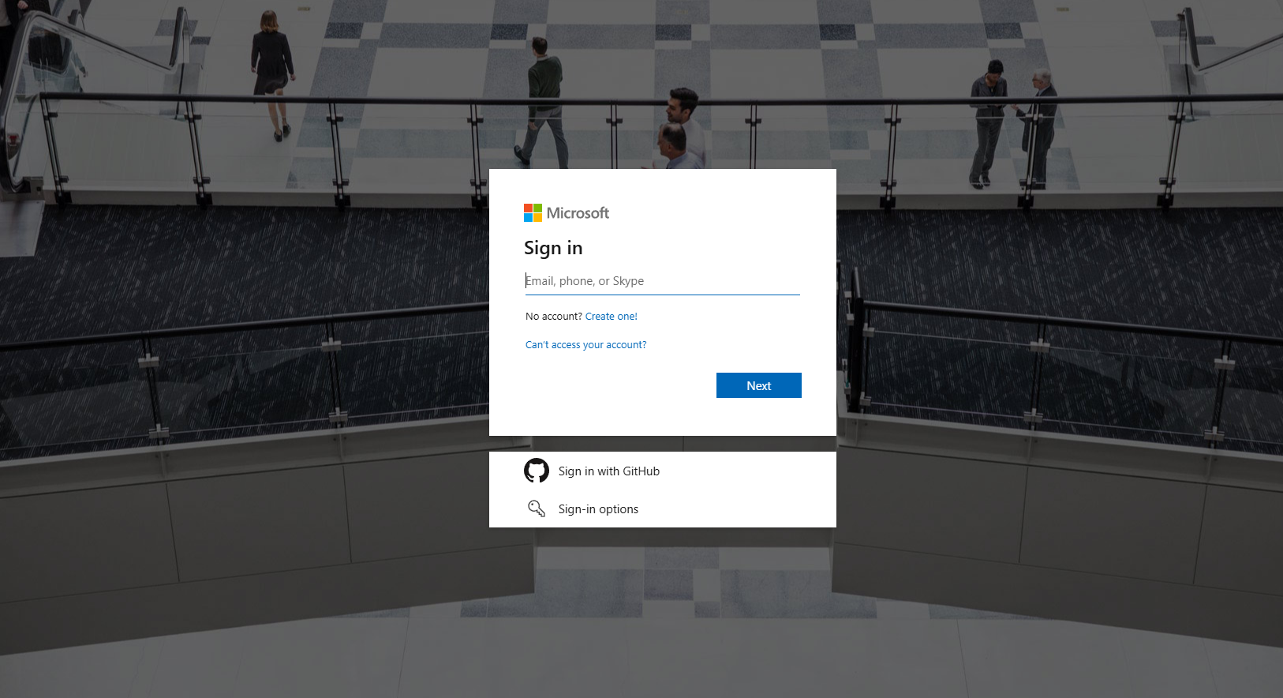

1. Add your Credit/Debit Card Details ( used for billing of the services used)

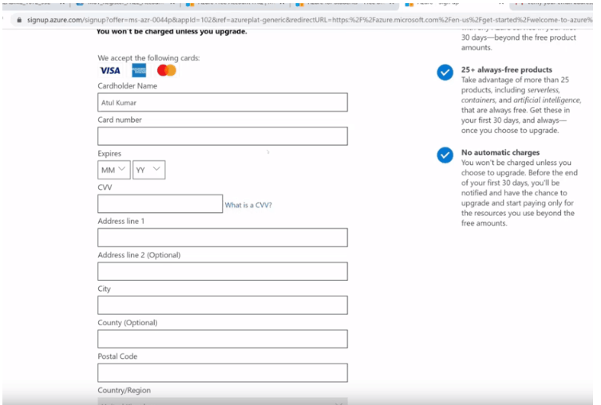

1. Setup your subscription (Free for 12 months in my case)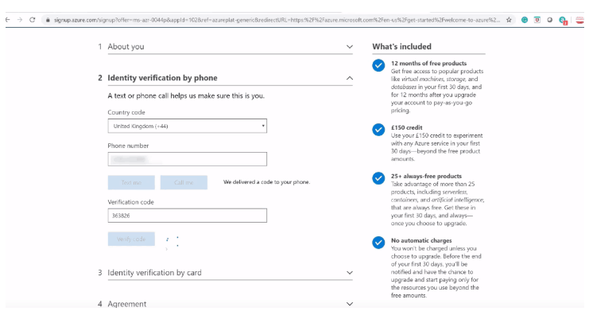
2. Explore Azure Portal

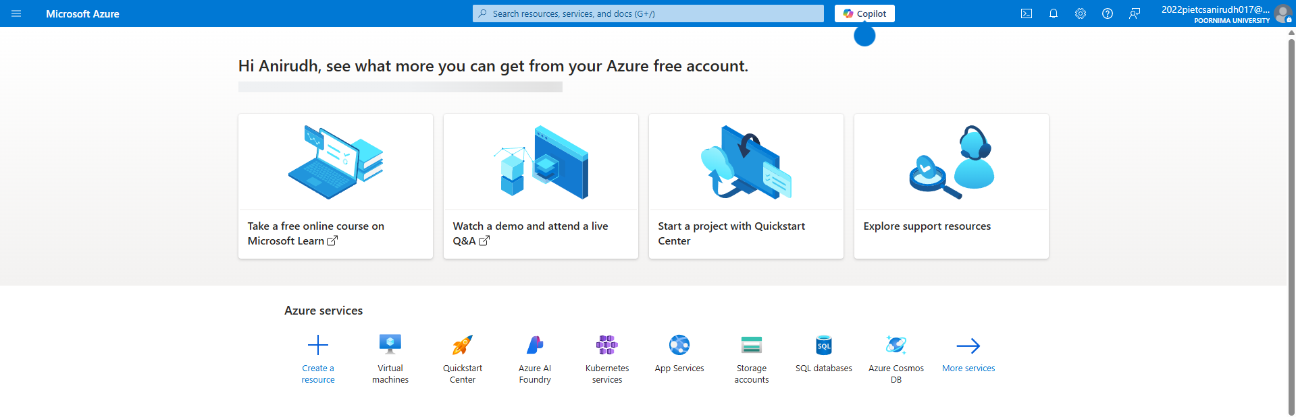

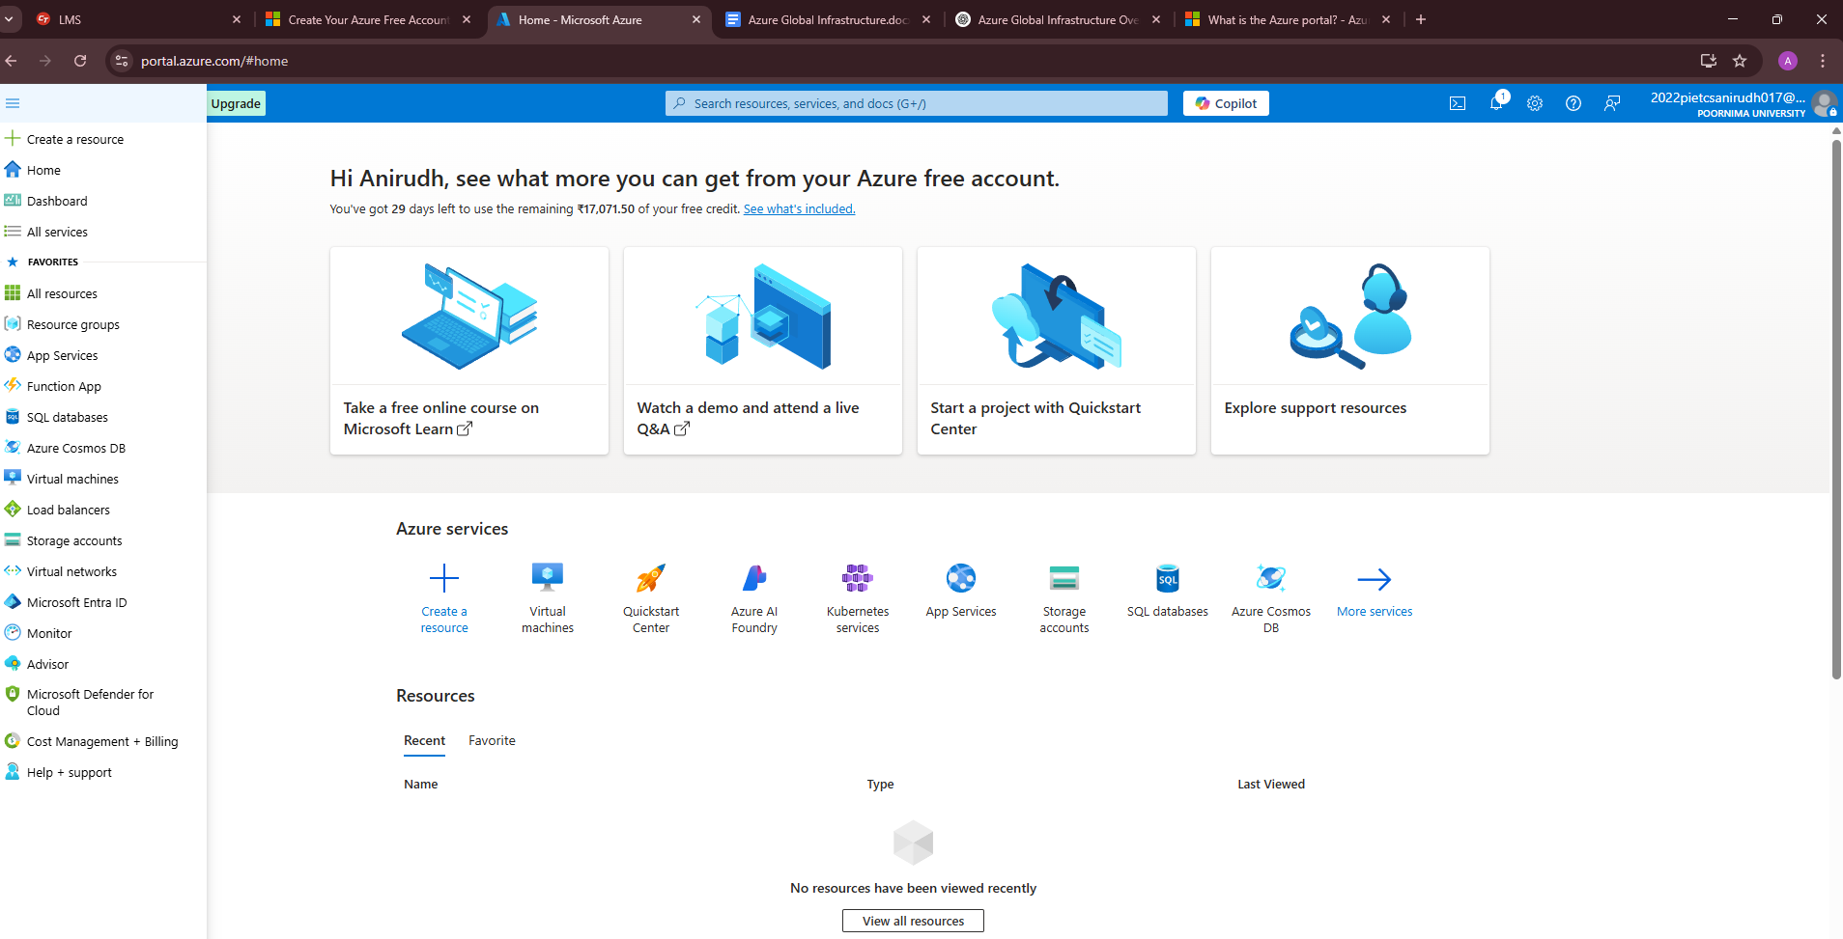

**Azure Portal Snapshot**

**Azure Global Infrastructure**

Azure regions, geographies, and Availability Zones are the foundation of Microsoft global infrastructure which provides high availability, disaster recovery and resiliency.

**Azure Regions :**

Azure Region is the physical datacentres placed inside a low-latency perimeter and connected through a dedicated high-bandwidth network connection.

Microsoft Azure has more Global regions than any other cloud provider.

Customers can leverage Azure regions to deploy applications where they need to in a flexible manner.

**Azure Geographies**

Azure geography is an area of the world that contains one or more Azure regions. Azure region is a very important concept because every time you create an azure resource like a virtual machine for example, you need to specify the region where you want the resource, in this case, the virtual machine to be created. An azure region may also be paired-up with another azure region and there are several benefits of this pairing. An azure region may also have availability zones.

**List of Azure Geographies & Regions**

| **Geography** | **Region** | **Location** | **Azure**  **Region** | **Data Center Location** |
| --- | --- | --- | --- | --- |
| Australia | [Australia Central](https://www.azurespeed.com/Information/AzureRegions/AustraliaCentral) | Canberra | Australia Central 2 | Australia |
| Australia | [Australia East](https://www.azurespeed.com/Information/AzureRegions/AustraliaEast) | New South Wales | Australia Southeast | Australia |
| Australia | [Australia Southeast](https://www.azurespeed.com/Information/AzureRegions/AustraliaSoutheast) | Victoria | Australia East | Australia |
| Brazil | [Brazil South](https://www.azurespeed.com/Information/AzureRegions/BrazilSouth) | Sao Paulo State | South Central US | US |
| Canada | [Canada Central](https://www.azurespeed.com/Information/AzureRegions/CanadaCentral) | Toronto | Canada East | Canada |
| Canada | [Canada East](https://www.azurespeed.com/Information/AzureRegions/CanadaEast) | Quebec | Canada Central | Canada |
| India | [Central India](https://www.azurespeed.com/Information/AzureRegions/CentralIndia) | Pune | South India | India |
| United States | [Central US](https://www.azurespeed.com/Information/AzureRegions/CentralUS) | Iowa | East US 2 | United States |
| Chile | [Chile Central](https://www.azurespeed.com/Information/AzureRegions/ChileCentral) | Santiago |  | Chile |
| Asia Pacific | [East Asia](https://www.azurespeed.com/Information/AzureRegions/EastAsia) | Hong Kong | Southeast Asia | Asia Pacific region |
| United States | [East US](https://www.azurespeed.com/Information/AzureRegions/EastUS) | Virginia | West US | United States |
| United States | [East US 2](https://www.azurespeed.com/Information/AzureRegions/EastUS2) | Virginia | Central US | United States |
| France | [France Central](https://www.azurespeed.com/Information/AzureRegions/FranceCentral) | Paris | France South | France |
| Germany | [Germany West Central](https://www.azurespeed.com/Information/AzureRegions/GermanyWestCentral) | Frankfurt | Germany North | Germany |
| Indonesia | [Indonesia Central](https://www.azurespeed.com/Information/AzureRegions/IndonesiaCentral) | Jakarta |  | Indonesia |
| Israel | [Israel Central](https://www.azurespeed.com/Information/AzureRegions/IsraelCentral) | Israel |  | Israel |
| Italy | [Italy North](https://www.azurespeed.com/Information/AzureRegions/ItalyNorth) | Milan |  | Italy |
| Japan | [Japan East](https://www.azurespeed.com/Information/AzureRegions/JapanEast) | Tokyo, Saitama | Japan West | Japan |
| Japan | [Japan West](https://www.azurespeed.com/Information/AzureRegions/JapanWest) | Osaka | Japan East | Japan |
| Korea | [Korea Central](https://www.azurespeed.com/Information/AzureRegions/KoreaCentral) | Seoul | Korea South | Korea |
| Korea | [Korea South](https://www.azurespeed.com/Information/AzureRegions/KoreaSouth) | Busan | Korea Central |  |
| Malaysia | [Malaysia West](https://www.azurespeed.com/Information/AzureRegions/MalaysiaWest) | Kuala Lumpur |  | Malaysia |
| Mexico | [Mexico Central](https://www.azurespeed.com/Information/AzureRegions/MexicoCentral) | Querétaro State |  | Mexico |
| New Zealand | [New Zealand North](https://www.azurespeed.com/Information/AzureRegions/NewZealandNorth) | Auckland |  | New Zealand |
| United States | [North Central US](https://www.azurespeed.com/Information/AzureRegions/NorthCentralUS) | Illinois | South Central US | the United States |
| Europe | [North Europe](https://www.azurespeed.com/Information/AzureRegions/NorthEurope) | Ireland | West Europe | Europe |
| Norway | [Norway East](https://www.azurespeed.com/Information/AzureRegions/NorwayEast) | Norway | Norway West | Norway |
| Poland | [Poland Central](https://www.azurespeed.com/Information/AzureRegions/PolandCentral) | Warsaw |  | Poland |
| Qatar | [Qatar Central](https://www.azurespeed.com/Information/AzureRegions/QatarCentral) | Doha |  | Qatar |
| South Africa | [South Africa North](https://www.azurespeed.com/Information/AzureRegions/SouthAfricaNorth) | Johannesburg | South Africa West | South Africa |
| United States | [South Central US](https://www.azurespeed.com/Information/AzureRegions/SouthCentralUS) | Texas | North Central US | United States |
| India | [South India](https://www.azurespeed.com/Information/AzureRegions/SouthIndia) | Chennai | Central India | India |
| Asia Pacific | [Southeast Asia](https://www.azurespeed.com/Information/AzureRegions/SoutheastAsia) | Singapore | East Asia | Asia Pacific region |
| Spain | [Spain Central](https://www.azurespeed.com/Information/AzureRegions/SpainCentral) | Madrid |  | Spain |
| Sweden | [Sweden Central](https://www.azurespeed.com/Information/AzureRegions/SwedenCentral) | Gävle | Sweden South | Sweden |
| Switzerland | [Switzerland North](https://www.azurespeed.com/Information/AzureRegions/SwitzerlandNorth) | Zurich | Switzerland West | Switzerland |
| UAE | [UAE North](https://www.azurespeed.com/Information/AzureRegions/UAENorth) | Dubai | UAE Central | United Arab Emirates |
| United Kingdom | [UK South](https://www.azurespeed.com/Information/AzureRegions/UKSouth) | London | UK West | United Kingdom |
| United Kingdom | [UK West](https://www.azurespeed.com/Information/AzureRegions/UKWest) | Cardiff | UK South | United Kingdom |
| United States | [West Central US](https://www.azurespeed.com/Information/AzureRegions/WestCentralUS) | Wyoming | West US 2 | United States |
| Europe | [West Europe](https://www.azurespeed.com/Information/AzureRegions/WestEurope) | Netherlands | North Europe | Europe |
| India | [West India](https://www.azurespeed.com/Information/AzureRegions/WestIndia) | Mumbai | South India | India |
| United States | [West US](https://www.azurespeed.com/Information/AzureRegions/WestUS) | California | East US | United States |
| United States | [West US 2](https://www.azurespeed.com/Information/AzureRegions/WestUS2) | Washington | West Central US | United States |
| United States | [West US 3](https://www.azurespeed.com/Information/AzureRegions/WestUS3) | Phoenix | East US | United States |

**From the above given regions , West India region is used by my account , since my location of using my azure account is in INDIA.**

### **Azure Availability Zones & Datacenters**

**Availability Zones** (AZs) are **physically separate locations** within an Azure region. Each zone is made up of **one or more data centers** with **independent power, cooling, and networking.** Availability zones are typically separated by several kilometers, and usually are within 100 kilometers. This distance means they're close enough to have low-latency connections to other availability zones through a high-performance network. However, they're far enough apart to reduce the likelihood that more than one will be affected by local outages or weather.

**Structure of AZs**

* Minimum of three zones per supported region
* Labeled as Zone 1, Zone 2, Zone 3
* You can deploy resources in a specific zone or make them zone-redundant (spread across all)

**Which Services Support AZs?**

* Azure Virtual Machines (VMs)
* Azure Kubernetes Service (AKS)
* Azure SQL Database (Zone-Redundant Configuration)
* Azure Load Balancer
* Azure Storage (ZRS – Zone-Redundant Storage)

### **Azure Data Center**

A **data center** is a **physical facility** that houses servers, networking equipment, storage systems, and security infrastructure. Microsoft owns and operates **hundreds of data centers** globally.

**Where Are Azure Data Centers Located?**

* United States: East US, West US
* Europe: North Europe (Ireland), West Europe (Netherlands)
* Asia: Southeast Asia (Singapore), East Asia (Hong Kong)
* Middle East, Africa, South America, Australia, and more

Datacenter locations are selected by using rigorous vulnerability risk assessment criteria. This process identifies all significant datacenter-specific risks and considers shared risks between availability zones.

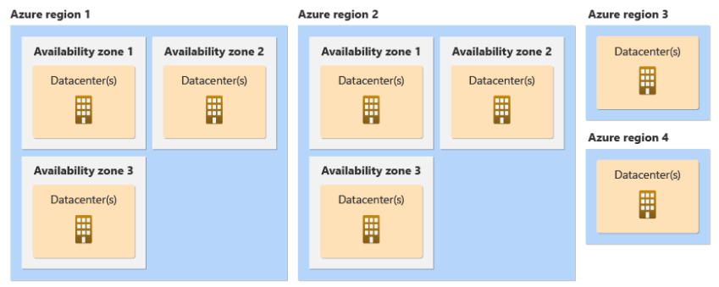

Azure Datacenters can be called as a subset of Availability Zones(AZ)

**References**

* **Microsoft Azure Documentation**
* **AZURE AZ-900 Fundamentals Documentation**
* **Youtube**
* **Microsoft Learn**